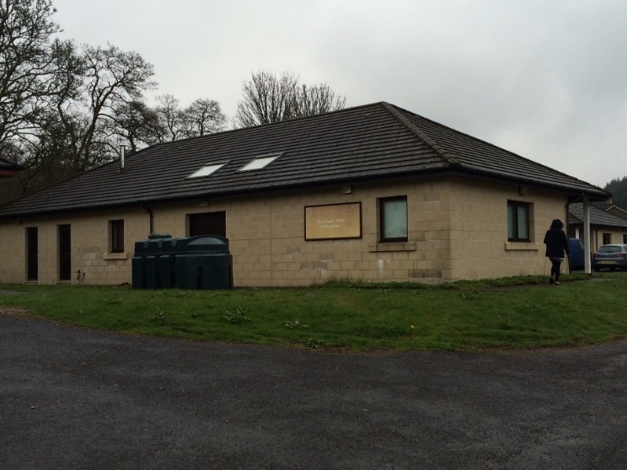
Location

Located in Kielder, next to Kielder Firs School and Kielder Castle Forest Park Centre.
Description

- Individual units ranging from 382 sq. ft. to 1442 sq. ft.

To let
Rivermead Workshops Kielder NE48 1HX
- Onsite parking
- 24-hour access
- Rural workshops
- Maintained and landscaped grounds

- Internal WC and kitchen facilities.
- Onsite parking.
- Flexible terms available.
- Maintained and landscaped grounds.

Accommodation

Unit | Size
4 | 1184 sq ft | 110 sqm
Rent (table)

Unit | Rent per annum | Rateable Value
4 | £3043.84 | £3150
Lease terms
By way of Internal Repairing Lease.
Flexible terms available.

Maintenance charge
Maintenance charge payable on all units plus VAT.

VAT
VAT will be charged where applicable.

EPC’s
EPC's will be available on request.

Rating
Rateable value payable depends on threshold, please contact your local authority.

Further information
Please direct all enquiries and viewing arrangements to Advance Northumberland Commercial team on 01670 528460 or commercial@advancenorthumberland.co.uk

Disclaimer
Advance Northumberland Commercial Ltd give notice that:
(i) the particulars are set out as a general outline only for the guidance of intending purchases or lessors and do not constitute, nor constitute part of, an offer or contract. (ii) all descriptions, dimensions, references to condition and necessary permission for use and occupation, and other details, are given in good faith and are believed to be correct but any intending purchasers or tenants should not rely on them as statements or representations of fact but satisfy themselves by inspection or otherwise as to the correctness of each of them.
(iii) no person in the employment of Arch Commercial Enterprise Ltd or any joint agents has any authority to make or give any representation or warranty whatever in relation to this property. (iv) all rentals and prices are quoted exclusive of VAT.

Rivermead Workshops, Kielder NE48 1HX

Advance Northumberland
Wansbeck Workspace Rotary Parkway Ashington
NE63 8QZ

01670 528 460
commercial@advancenorthumberland.co.uk www.advancenorthumberland.co.uk

