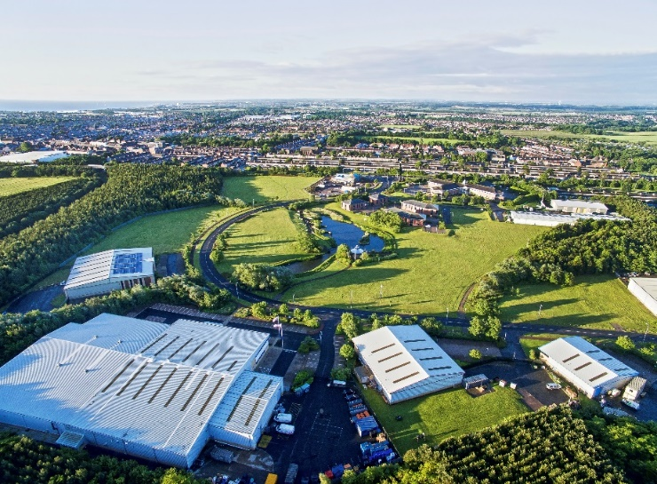
Location

Located south west of Ashington town centre with direct links to A189 and A1.

Description

- The park provides a mix of business accommodation in a quality landscaped and natural woodland setting complete with a lake.

Land Available
Wansbeck Business Park, Ashington NE63 8QZ
- 0.12 acres to 0.49 acres available
- long leasehold

- The park Is located on the former Ashington Colliery site with links to the A189 and A1.
Terms

POA.
Development opportunities

Sites available for various uses, details on application.
VAT

VAT will be charged where applicable.

Further information

Please direct all enquiries and viewing arrangement to Advance Northumberland Commercial team on 01670 528460 or commercial@advancenorthumberland.co.uk
Disclaimer
Advance Northumberland Commercial Ltd give notice that:
(i) the particulars are set out as a general outline only for the guidance of intending purchases or lessors and do not constitute, nor constitute part of, an offer or contract. (ii) all descriptions, dimensions, references to condition and necessary permission for use and occupation, and other details, are given in good faith and are believed to be correct but any intending purchasers or tenants should not rely on them as statements or representations of fact but satisfy themselves by inspection or otherwise as to the correctness of each of them.
(iii) no person in the employment of Arch Commercial Enterprise Ltd or any joint agents has any authority to make or give any representation or warranty whatever in relation to this property. (iv) all rentals and prices are quoted exclusive of VAT.

